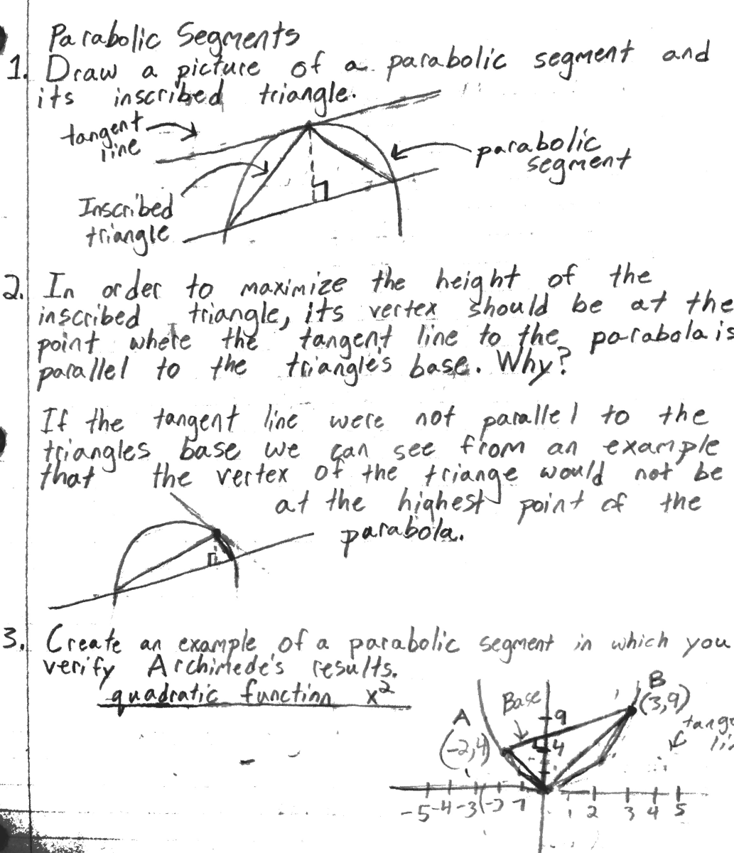[1]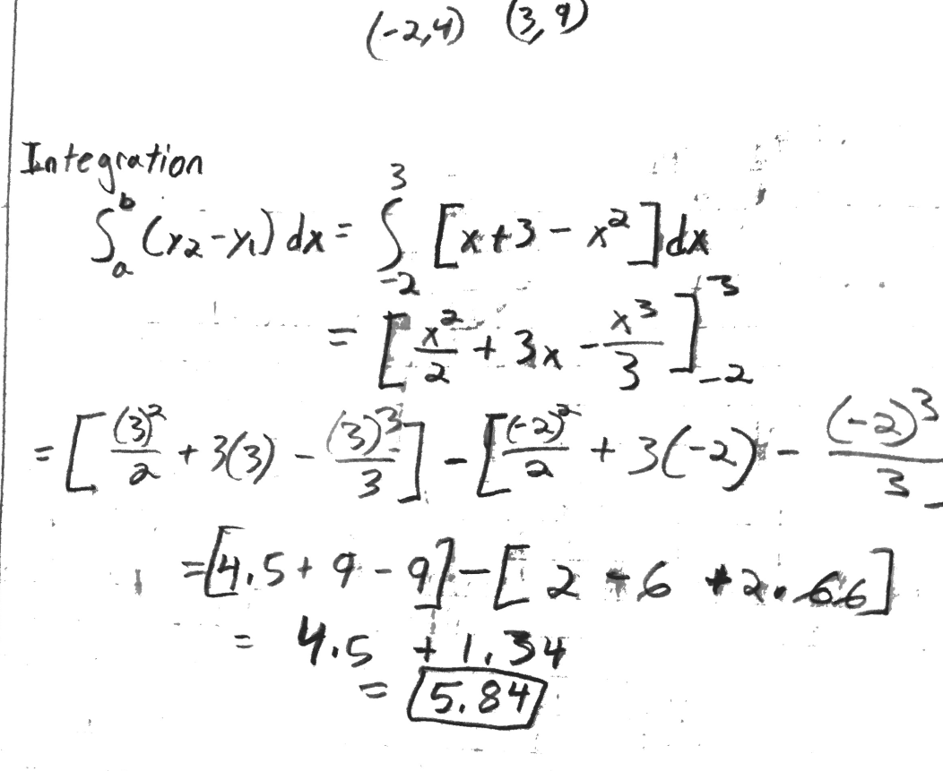

1. Help with Question 3 from wyzant.com and intmath.com